Primitive Data types
Data types in Java specify the size and type of values that a variable can store. Java is a strongly typed language, meaning every variable must be declared with a specific data type before it can be used.
Java data types are divided into two main categories: Primitive and Non-Primitive.

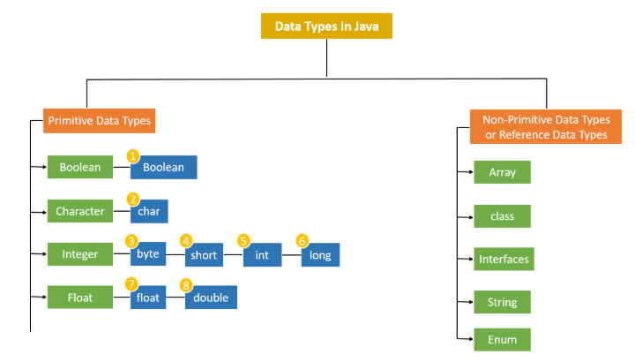

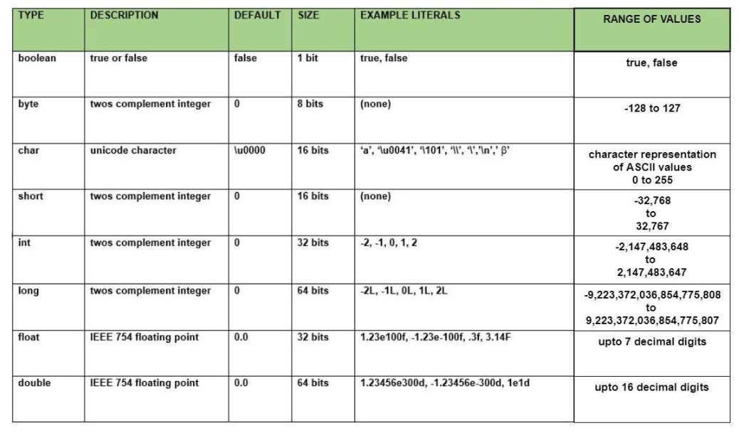

Numeric Types (Integers): Used to store whole numbers without decimals.
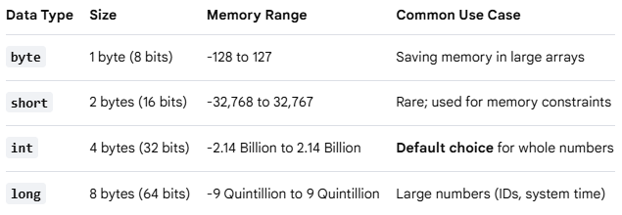
Note: When assigning a value to a long, append an L or l to the end of the number (e.g., long population = 8000000000L;)

Numeric Types (Floating-Point): Used to store fractional numbers containing decimals.
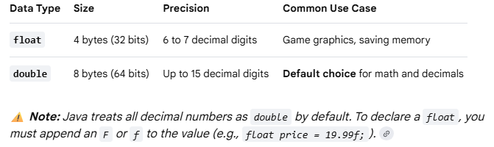

Character Type: Used to store a single character.
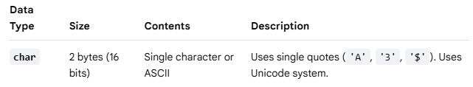
Boolean Type: Used to store conditional states.
